Thurrock Council

Property Licensing under the Housing Act 2004

Declaration that a property is not   
licensable

Please note that is it an offence to provide false information and that the council will verify the   
information given (see notes on page 3)

**Address of property:**

**I declare that I am the person in control of the above-mentioned property and confirm that this property is exempt from licensing under parts 2 & 3 of the Housing Act 2004 due to the following:** (Please tick where appropriate)



Postcode:

The property is owner occupied Owner Occupied with only one or two

With no lodgers 🞏 lodgers 🞏

The property is solely occupied by The full Term of the tenancy is

the owners relatives 🞏 more than 21 years 🞏

The property is managed/controlled by either the local Housing/Health/Police/Fire Authority 🞏

(Please attach to this form the confirmation agreement or booking form in place from the controlling authority)

The property is used as holiday lets only 🞏

Please state in writing how many calendar days a year the property is used as holiday lets

|  |
| --- |
|  |

Other 🞏

**Please complete in clear capitals:**

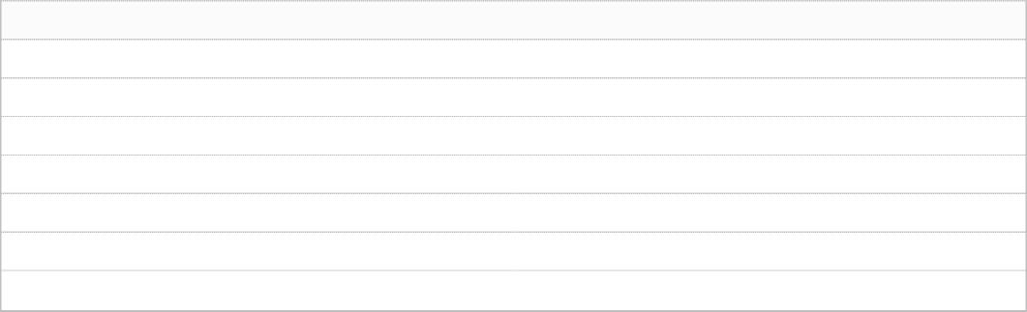

If ‘other’ please state reason in writing:

I agree to inform the Council of any change in circumstances which would mean the property requires licensing.



First Name(s)

Surname

Address:

Postcode:

Telephone No.

Nature of Interest in property:

**Please give details of any other person/s that may have an interest in this property**



Signature:

Date:

I agree to inform the Council of any change in circumstances which would mean the property requires licensing.



First Name(s)

Surname

Address:

Postcode:

Nature of Interest in property:

Telephone No.

**Please see notes overleaf:**



Signature:

Date:

Page 2 of 3

**NOTES:**

**Housing Act 2004 - Section 238 - False or misleading information**

(1) A person commits an offence if—

1. he supplies any information to a local housing authority in connection with any of their functions under any of Parts 1 to 4 or this Part,
2. the information is false or misleading, and
3. he knows that it is false or misleading or is reckless as to whether it is false or misleading.

(2) A person commits an offence if—

1. he supplies any information to another person which is false or misleading,
2. he knows that it is false or misleading or is reckless as to whether it is false or misleading, and
3. he knows that the information is to be used for the purpose of supplying information to a local housing authority in connection with any of their functions under any of Parts 1 to 4 or this Part.

(3) A person who commits an offence under subsection (1) or (2) is liable on summary conviction to a fine not exceeding level 5* on the standard scale.

**\*currently unlimited\***

(4) In this section “false or misleading” means false or misleading in any material respect.

Page 3 of 3